## Select by Clicking

Simply click once on your desired object and it will become selected. You will notice a number of new controls are displayed.

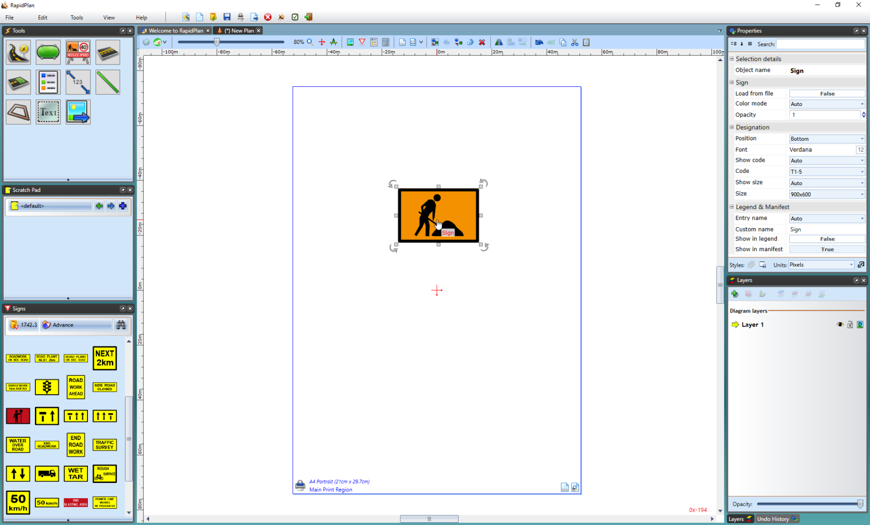

Selected_sign